Questacon Social Scripts
Social scripts are for families and teachers visiting Questacon with children and adults on the Autism spectrum. Below are social scripts for:
- School visits
- Family visits with young children
- Family visits with older children/adults
- Earthquake Lab (high sensory exhibit)
- Caged Lightning (high sensory exhibit)
- Free Fall (high sensory exhibit)
Written in consultation with Marymead’s Autism centre (formerly the AAACT), the scripts contain images that provide information on what a visit to Questacon may include. Scripts can be read online, downloaded, or copied and pasted to create a tour through Questacon that best suits your needs (www.questacon.edu.au).
High and low sensory spaces
Questacon is a vibrant, active and dynamic centre and may be confronting to sensitive visitors. Please use our Visitor Health Information Sheet to identify high and low sensory spaces within Questacon to coordinate an enjoyable experience suitable to the needs of your family member or student.
Calming spaces, identified on the Visitor Health Information Sheet, are quieter areas that are bright, have fewer people and usually have no multimedia.
High sensory spaces, identified on the Visitor Health Information Sheet, are busy places with a mix of multimedia, loud noises and/or low light. Galleries Three (Awesome Earth) and Seven (Excite@Q) are busy galleries which some visitors may find confronting. Some Spectacular Science Shows (i.e. The BOC Liquid Nitrogen Show, Rockets #101) include loud noises that may also be confronting.
Questacon’s Sensory Sensitivity Visitor Health Information Sheet can be collected from the Questacon Ticket Desk and/or Information Desk or downloaded from our website.
Quiet times
Questacon tends to be quieter between 3:30pm and 5:00pm on weekdays during term time. February is our quietest month. You can call us on 6270 2800 to check what upcoming days are expected to be quiet.
Avoid queues
A school, or home school family, with students on the Autism spectrum can minimise the time spent in a queue by securing a group booking. Group Bookings can be secured by contacting 02 6270 2893 or via email at group.bookings@questacon.edu.au. Gift cards can also be pre-purchased over the phone or through our online shop and allow you to use the quicker Pre-paid queue.
Feedback
We'd love to hear what you think about these social scripts and whether they are helpful to you. Please send your feedback to info@questacon.edu.au.

Social Scripts for School Visits
What is Questacon?
Questacon is a museum where I can learn, through play, about science and technology.
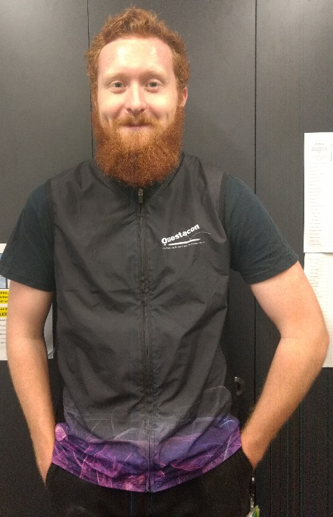
People who work at Questacon
Questacon gallery staff wear black clothes, colourful Questacon vests and straps with name tags around their necks. I can ask these people for help if I can’t find my school group or teacher.
Arrival
When I arrive at Questacon either a staff member, or my teacher, will talk to my class and show me where I need to go from the ground floor entrance. There might be a lot of other schools visiting Questacon as well.
Toilets
I will tell my teacher if I need to go to the toilet.
Storing our bags
School bags can be stored in your bus or locked in secure cages inside Questacon. I will enter Questacon through sliding doors and can put my school bag away with the rest of my class.
I can take my wallet out of my school bag if I am going to the Questacon shop. The bus driver or a teacher will put my, and the rest of the classes, shopping on the bus. I can get my school bag back, if it locked in a cage, when I leave Questacon.
Exploring Questacon
I might see exhibitions and science shows at Questacon. I can play with most exhibits. My teacher will tell me what my class is doing and when.
Visiting the Questacon shop
My teacher will tell me if, and when, we are going to the shop. When I have finished shopping I will wait with my group until the teacher tells my class what it is doing and when.
Eating
My teacher will tell me when it is time to eat. When it is time to eat I will get my food and sit with my class. There may be other school students eating lunch at the same time.
Some important things to remember when visiting Questacon
When I visit Questacon I must remember to:
- Follow the adult who is leading my group
- Stay close to my group
- Walk between activities
- Speak with my quiet voice, even though it may be noisy
- Take turns with other children
- Wait patiently when I have to line up
- Only touch things I am told that I am allowed to
Visiting Gallery Three (Awesome Earth)
Earthquake Lab
In Gallery Three (Awesome Earth) my school might visit the Earthquake Lab. I might have to wait in line outside this room until a staff member lets me in. There are two things that happen in the Lab at the same time: a talk about earthquakes and I can build towers with the blocks in the Lab. A staff member will tell me when I can start building.
In the Earthquake Lab the floor moves from side to side and is noisy.
The room is bright and there is multimedia on the wall. The room has a big window so that I can see Caged Lightning. If the Lab is too noisy or the moving floor makes me dizzy I can leave the Lab. I will wait for the teacher to let me know when I can leave with my school group.
Caged Lightning
In Gallery Three (Awesome Earth) my school might see Caged Lightning. The room is dark to see the lightning.
The lightning goes off every 15 minutes. The lightning discharge is noisy and there might be other school groups watching. They might be excited and noisy when the lightning happens.
If the lightning is too noisy or too bright I can close my eyes or block my ears. I will wait for the teacher to let me know when I can leave with my school group.
Visiting Gallery Seven (Excite@Q)
Gallery Seven has low light and can be noisy and hot in summer.
Freefall
In Gallery Seven (Excite@Q) my school might do the Freefall. The freefall is a big slide. I might have to wait in line at this exhibit until a staff member lets me up the stairs.
The staff member at the bottom of the Freefall slide will ask me to put on orange overalls and blue booties if I don’t have any socks while waiting in line. I will take off my shoes and put them into a pigeon hole. To make sure it’s safe to do the freefall the staff member will ask the group that they are not injured or pregnant, can hold their own body weight and to make sure they do not have anything in their back pockets.
The staff member at the top of the Freefall will talk to the group about some safety tips and on how to do the Freefall safely. The staff member will have to gently touch my back to help me do the Freefall safely.
If I feel scared, dizzy or it is too noisy I can decide not to do the Freefall at any time. If so, I can walk back down the stairs and take off the orange jump-suit. I will put my shoes back on and will wait for the teacher to let me know when I can leave with my school group.
Visiting a Spectacular Science Show
My school might have booked to see a 30 minute show in the Japan Theatre or the Blue Door Room. I might have to line up outside the doors for a few minutes before the show starts and the doors open. I will wait outside for a staff member to open the doors to the Theatre or Blue Door Room and then sit with my group. I will watch a show with demonstrations at the front. If I put my hand up when asked, I might be chosen as a volunteer or to answer a question.
The presenter will tell the audience when the show is finished and my teacher will take us outside the theatre and tell us what to do next.
My teacher will tell me if the show we are seeing has loud noises or not. If it is too loud I am allowed to cover my ears. I can also cover my eyes any time. I will tell my teacher if I need to leave the Japan Theatre or Blue Door Room during the show.
Leaving
When it is time to go home, I will go downstairs and leave through the automatic sliding doors and get back on to the bus.
Going to Questacon is fun.

Social scripts for family visits with young children
My Exploration of Questacon
I am going to Questacon.
I will have to wait with an adult to buy tickets to Questacon. We can decide which shows to see.
I can get a map of Questacon at the Ticket desk or the Information desk.
Questacon can be very exciting. I will remember to walk and use my quiet voice when I am inside.
I might wait to see, touch and do things at Questacon. I might not have time to see everything.
Sometimes it can be noisy and busy at Questacon.
There are quiet places inside and outside at Questacon where I can rest with my family.
I will stay with my family while I am at Questacon.
If I see a show at Questacon, I will stay in my seat to watch. There may be a lot of excitement and loud noises.
There are special areas I can eat or drink at Questacon. I am not allowed to eat or drink in the exhibitions.
If we buy food from the café I might need to line up. It can sometimes be noisy and busy in the café.
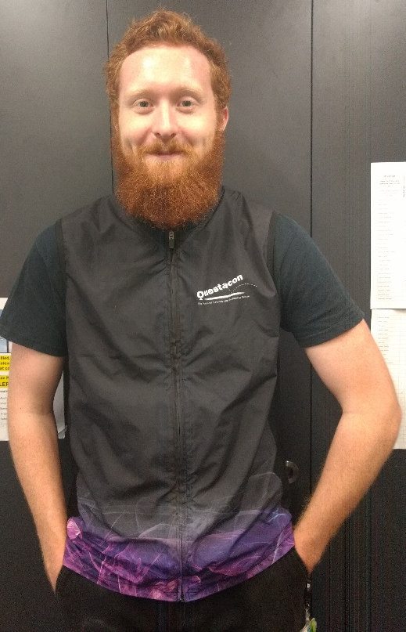
There are some family toilets we can go to together. We can check the map or ask a staff member. The hand dryers are noisy but they dry hands very fast and can be fun!

If I get lost, I will ask people who work at Questacon for help. They are wearing black clothes, colourful vests and straps around their neck.

I am going to learn, explore and have fun at Questacon!

Social scripts for family visits with older children and adults
What is Questacon?
I am going to Questacon. Through play or by watching shows, I can explore and learn all about science and technology.
Getting Tickets
I will enter the museum through automatic sliding doors. I might need to wait in line with my family to buy tickets. A staff member will talk to us about any shows or special exhibitions on that day.
Exploring Questacon
There are lots of exhibitions to visit at Questacon. Sometimes there are lots of people visiting Questacon and it can be noisy. I might need to wait in line to see things, touch things and do things at Questacon. I might not have time to see everything.
Finding out what we can do at Questacon
I can get a map of Questacon from the Ticket desk or the Information desk to find out what I can see and do. My family can choose to store our bags in a locker if they don’t want to carry them and when it’s time to leave we can collect our bags.
Staying with my family
It can be exciting at Questacon. I will do my best to stay calm, speak in a quiet voice and walk inside the centre. I need to stay with my family while I am visiting Questacon.
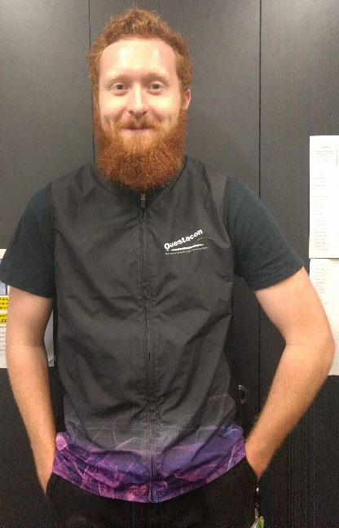
Staff who can help
If I am lost or have a question, staff at Questacon can help me. They wear black clothes, colourful vests and straps with name-tags around their neck.
Quiet spaces
There are quiet places at Questacon where I can relax with my family. I can find these on the Sensory Map.
Seeing a Spectacular Science show
If I see a special show in the Japan Theatre or the Blue Door Room, there may be a lot of people, loud noises and it may be dark as this helps to see the show better. I might feel a bit scared but it will be okay because I will be with my family.
In some shows the performer likes to talk with the audience. I can talk to the performer when this happens if I want to but I don’t have to talk if I don’t want to. The theatre might get noisy when this happens but it will be okay because I will be with my family.
I will stay in my seat to watch and learn. I will sit in a seat close to the stairs in the Japan Theatre so if I need to, I can leave the Theatre easily.
If I put my hand up when asked, I may get chosen to answer questions or come to the front as a helper. If I have more questions, I can talk to the presenter after the show is over.
Activities at Questacon
Sometimes there are activities at Questacon. I might make something or do an experiment. I will listen and follow instructions by Questacon staff. My family can help me with this activity.
Food and eating at Questacon
There are special areas I can eat or drink at Questacon. Food and drink are not allowed in the Galleries. If we bring food from home, I can eat it anywhere outside or at the tables in the foyer.
There is a café at Questacon. If we want to buy food, I might need to line up. The café may be busy inside.
Toilets at Questacon
To find a toilet, I can look for signs, check the map or ask a staff member. The hand dryers are noisy but they dry hands fast.
Questacon’s Science Garden
Outside, I can sit on the grass or seats with my family and explore the exhibits in the Questacon Science Garden. The Science Garden goes all the way around the Questacon building. From the rear Science Court I can see the National Library, the lake and the water fountain. From the ceremonial entrance I can see the lake, the Portrait Gallery, the High Court, the National Art Gallery and Old Parliament House. There might be school groups outside eating, exploring or playing.
Social scripts for the Earthquake Lab
What is the Earthquake Lab?
The Earthquake Lab is a room that simulates low to moderate level earthquakes.
The exhibit challenges visitors to build structures that can withstand an earthquake.
Outside the Earthquake Lab
In Gallery Three (Awesome Earth) I might visit the Earthquake Lab. I might have to wait in line outside this room until a staff member lets me in. I might have to share my visit to the Earthquake Lab with other families or school groups. Sometimes it can be noisy in the Earthquake Lab if people are excited.
Inside the Earthquake Lab
There are two things that happen in the Lab at the same time: a talk about earthquakes and I can build towers with the blocks in the Lab. A staff member will tell me when I can start building. The staff member will do three to four tremors with each group. Some staff members let visitors sit, or lie, down to experience the tremor in a different way. I can choose not to sit down or lie down if I want to.
The room is bright and there is multimedia on the wall.
Each tremor goes for 20 seconds and the floor moves from side-to-side. A loud noise happens when the moderate and large earthquakes begin. If I feel dizzy when the floor moves I can leave the Earthquake Lab at any time.
The room is bright and there is multimedia on the wall. Staff members stand behind the building area, on one side of a barrier, and a sliding door is noisy as it opens and closes.
To replicate shifting soil, Questacon uses corn kernels as a foundation. The corn kernels should not be eaten. If I am allergic to corn I should not go into the Earthquake Lab.
I can see Caged Lightning from inside the Earthquake Lab. Caged Lightning is bright and noisy. Sometimes the gallery is noisy because other visitors are excited to see Caged Lightning. If the lightning is too noisy or too bright I can close my eyes or block my ears.
Leaving the earthquake Lab
After the last tremor the staff member will say that I can leave the Lab and continue to explore Questacon.

Social scripts for Caged Lightning
What is Caged Lightning?
A tall Tesla Coil discharges every 15 minutes
Watching Caged Lightning
Gallery Three is dark to provide a better view of a number of exhibits.
The discharge of lightning is safe. Once the lightning happens the Tesla Coil automatically restarts the process. Sometimes the discharge fails and no lightning is produced.
There might be other families or school groups watching Caged Lightning.
Caged Lightning is bright, noisy and sometimes a lot of people gather to watch it discharge. Sometimes the gallery is noisy because other visitors are excited to see Caged Lightning. If the lightning is too noisy or too bright I can close my eyes or block my ears.

Social scripts for Freefall
What is Freefall?
Freefall is a tall slide that lets you experience zero gravity and the fear response.
Gallery Seven (Excite@Q) is a low light room that is noisy. Gallery Seven is generally Questacon’s busiest gallery and is very popular with school groups. In summer it can be hot.
Before Freefall
For safety and communication reasons only 10-15 visitors can experience Freefall. Because of this I might have to wait in line at this exhibit until a staff member lets me up the stairs. Sometimes the line can include a lot of people from families and school groups.
The staff member at the bottom of the Freefall slide will ask me to put on orange overalls and blue booties if I don’t have any socks while waiting in line. I will take off my shoes and put them into a pigeon hole. If I have a bag I will leave it with my shoes.
To make sure it’s safe to do the freefall the staff member will ask the group that they are not injured or pregnant, can hold their own body weight and to make sure they do not have anything in their back pockets. You can do Freefall if you are five or older, are taller than 110cm, don’t have any injuries or recent surgery, can hold your own body-weight and follow safety instructions from the staff member at the top of Freefall.
If I feel scared, dizzy or it is too noisy I can decide not to do the Freefall at any time. If I decide not to do Freefall at the bottom of the slide I can take off, and return, my orange jump-suit to the staff member. I will collect my shoes and continue to explore Questacon.
During Freefall
The staff member at the top of the Freefall will talk to the group about some safety tips and on how to do the Freefall safely.
The staff member will have to gently touch my back to help me do the Freefall safely.
The top of the Freefall slide can be hot, bright and noisy. Multimedia is present at the top of the slide.
Sometimes the horizontal bar will have to raised or lowered. This safety feature is dependent on the height of the visitor experiencing Freefall.
Safety tips include:
- Standing against the orange wall;
- Not crossing the yellow/black line until called;
- Tying, or pulling aside, long hair; and
- No peer group pressure.
How to Freefall Instructions include:
- Holding on to the bar with both hands;
- Sliding off the edge and holding your body-weight;
- Looking down to your toes;
- Holding on for the verbal count of 3 (3-2-1) before letting go; and
- Keeping hands in the air.
If I feel scared, dizzy or it is too noisy I can decide not to do the Freefall at any time. If so, I can walk back down the stairs and take off the orange jump-suit. I will put my shoes back on, collect my bag if I have one, and continue to explore Questacon.

After Freefall
If I choose not to do Freefall from the top of the exhibit I will walk down the stairs and return the orange jump-suit to the staff member at the bottom of the slide. I will collect any belongings such as shoes and bags.
If I do Freefall, at the bottom of the slide I am to stand up and walk safely off the slide. I will take off, and return, the orange jump-suit to the staff member at the bottom of the slide. I will collect any belongings such as shoes and bags.

